Sustainable Aviation Fuel Certificate Rulebook
Version 1
Draft for public consultation
Table of Contents
1 Background and Scope 3
2 General Provisions 3
2.1 The Sustainable Aviation Fuel Certificate Registry 3
2.2 Normative References 3
2.3 Terms and Definitions 3
3 Units in the Registry 7
3.1 General Provisions on Units 7
3.2 Sustainable Aviation Fuel Certificates (SAFcs) 7
3.3 SAF End-user Reduction Claims (SERcs) 8
3.4 Unit Types 8
3.5 Sustainability Criteria at SAFc Issuance 11
3.6 Validated and Verified Units 13
3.7 Unit Validity Period 14
3.8 Unit Status 14
4 Accounts and Account Holders 14
4.1 Account Types 14
4.2 Account Status 16
4.3 Setting up a Company in the Registry 16
4.4 Opening Fuel Provider Holding Accounts 17
4.5 Opening Other Accounts 17
4.6 Blocking an Account 18
4.7 Closing Accounts 18
5 Certification Bodies and Auditors 18
5.1 Registering a Certification Body in the Registry 18
6 Transactions 19
6.1 General Rules for All Transactions 19
6.2 Issuance of SAFcs 19
6.3 Issuance of SERcs 20
6.4 Transferring Units 20
6.5 Retirement of SAFcs 20
6.6 Retirement of SERcs 21
7 Processes 21
7.1 Verification 21
7.2 Unit Type Conversion by an Account Holder 22
7.3 Suspension and Unsuspension of Units 22
7.4 Withdrawal, Deletion, and Expiry 23
8 Tables 23
8.1 The Table of Certifications 23
8.2 The Proof of Sustainability (POS) Table 23
8.3 The Book and Claim Retirement Table 24
9 Confidentiality and the Public Website 24
9.1 Confidentiality 24
9.2 Public Website of the Registry 25
9.3 Statements of Retirements 25
10 Technical Requirements of the Registry 25
10.1 IT Requirements of the Registry 25
10.2 Availability and Reliability of the Registry 25
11 Management of the Registry 26
11.1 The Registry Administrator 26
11.2 The Registry Governance Board 26
12 Annex A: Information to Be Provided for Establishing an Entity in the Registry 27
13 Annex B: Company Representatives and Authorized Representatives 28
13.1 Setting up a CR 28
13.2 Setting up an AR 28
13.3 Rights of ARs 30
13.4 Updating Information on Accounts, Company Representatives, and Authorized Representatives 31
14 Annex C: Government Support Mechanisms 31
15 Annex D: Information to Be Provided by the Fuel Provider When Requesting the Issuance of SAFc (POS INFO) 32

Background and Scope

This Rulebook describes the detailed functioning of sustainable aviation fuel (SAF) certificates and end-user reduction claims, including functionality of the Sustainable Aviation Fuel Certificate Registry. The purpose of the Rulebook is to: a) describe the detailed functioning of the Registry system and b) describe what account holders can do in the Registry.

The Rulebook is intended to conform with the requirements of the Book & Claim Manual issued by the Roundtable on Sustainable Biomaterials (RSB). The conformity of the final version will be evaluated by RSB. This Rulebook was developed by RMI and the Environmental Defense Fund, in consultation with RSB, Sustainable Aviation Buyers Alliance (SABA) members, a consultative group of fuel providers, and other stakeholders, and is now under public consultation.

General Provisions

The Sustainable Aviation Fuel Certificate Registry
The Sustainable Aviation Fuel Certificate Registry (the Registry) is a standardized electronic database that enables — inter alia — the issuance, holding, transfer, and retirement of units. The Registry controls and checks every transaction to ensure conformity with this Rulebook. The Registry shall be operated and maintained in accordance with the provisions of the Rulebook by the Registry Administrator.

Normative References
The following referenced documents are indispensable for the application of this document. For dated references, only the cited edition applies. For undated references, the latest edition of the referenced document (including any amendments) applies.
- RSB Book & Claim Manual
- International Civil Aviation Organization (ICAO) Carbon Offsetting and Reduction Scheme for International Aviation (CORSIA)
- Science Based Targets initiative (SBTi) aviation sector guidance
- Greenhouse Gas Protocol
- SABA Sustainability Framework

Terms and Definitions
For the purposes of this Rulebook, the following definitions shall apply:

Air transport provider | An entity that provides aviation services for passengers and/or freight, inclusive of airlines, freight carriers, and private aircraft.
Account | An up-to-date record in the Registry of all the units held by an account holder, from which an account holder can initiate transactions (issuance, transfer, and retirement of units). Account permissions vary by type (see Section 3.8).
Account holder | The legal or natural person holding an account in the Registry.
Auditor | A natural person empowered by a certification body authorized under a sustainability certification scheme (i.e., accredited) to carry out company and site audits to issue certifications or recertifications.
Authorized representative | A natural person acting on behalf of an account holder.
Book and claim | A chain-of-custody model in which the administrative record flow is not necessarily connected to the physical flow of material or product throughout the supply chain.
Certificate | A transferable electronic unit in the Registry that represents the environmental attributes of a metric ton of neat SAF. SAFcs and SERcs are both certificates.
Certification | An independently evaluated record that an entity holds that serves as evidence that its products and services meet specific eligibility criteria as defined in a sustainability certification scheme (SCS) and as assessed by an accredited certification body. Certification, as used in this Rulebook, is only used with respect to the mass balance chain-of-custody system.
Certification body | An independent organization of auditors who carry out site and company audits to determine if a facility meets the requirements of an SCS.
Claim | Declared information regarding the specified characteristics of a material or product.
End-user | A user of aviation services, such as a business with passenger travel and/or an air freight footprint.
Environmental Attributes | The sustainability characteristics of any given unit and its associated fuel volume, as evaluated through certification. The lifecycle emissions reduction of any given fuel volume as compared to conventional jet fuel is a key environmental attribute.
Freight forwarder | A company that arranges aviation services on behalf of end-users of freight transport (also known as a logistics service provider).
Issuance | The process of creating a new SERc or SAFc in an account in the Registry.
Lifecycle | For the purpose of this rulebook, lifecycle refers to the scope of the assessment of SAF’s impact. The SAFc system follows the convention set by ICAO CORSIA and SBTi, which evaluates the impact of SAF with a lifecycle assessment (LCA) from well to wake – or from feedstock origin to combustion of the fuel.
Mass balance | A chain-of-custody model in which materials or products with a set of specified characteristics are mixed according to defined criteria with materials or products without that set of characteristics.
Noncompliance | Any event or circumstance after unit issuance causing a deviation from the initial certification body evaluation of a facility under an SCS that would cause the fuel provider to no longer meet the performance criteria for a unit type, as evaluated by a certification body.
Process | An automated technical means to carry out an action relating to an account or a unit in the Registry.
Registry | A system for storing electronic data that makes it possible to repeatably and efficiently register, issue, hold, transfer, and retire units. A registry fulfills the capabilities described in the RSB Book & Claim Manual and holds formal recognition by RSB (the Roundtable on Sustainable Biomaterials).
Registry Administrator | The entity managing the daily operations of the Registry.
Registry Governance Board | A multilateral group that governs the Registry, which represents user types in the Registry and other organizations working on book-and-claim systems for SAF.
Retirement | In the case of SAFc, retirement is the irrevocable transfer of a SAFc to a retirement account, which amounts to a declaration by the holder of a SAFc that it wishes the SAFc to be accounted for as part of its emissions disclosure.  In the case of SERc, retirement is the irrevocable transfer of a SERc to a retirement account, which amounts to a declaration by the holder of a SERc that it wishes the SERc to be accounted for as part of its emissions disclosure and wishes to be added as an end-user beneficiary to the retirement of the SAFc that served as the basis for the issuance of the SERc.
Sustainability certification scheme (SCS) | A standard held by ISCC (the International Sustainability and Carbon Certification system) or RSB (the Roundtable on Sustainable Biomaterials) or any other standard holder that defines and details methods to evaluate the sustainability performance criteria of SAF supply chains, as can be evaluated by an accredited third-party certification body in a mass balance chain-of-custody system. Examples of SCSs include RSB and ISCC CORSIA, RSB EU RED, ISCC EU, ISCC Plus, and RSB Global.
Sustainability certification scheme (SCS) holder | ISCC, RSB, or any other recognized nonprofit organization that defines and details methods to independently evaluate the sustainability performance criteria of SAF supply chains.
SAF end-user reduction claim (SERc) | A unit that represents the unbundled end-user claims pertaining to a SAFc. Through retiring the SERc, the holder of the SERc can then claim reductions in its air travel–related emissions.
Sustainable aviation fuel (SAF) | Renewable or waste-derived drop-in aviation fuel that meets certain sustainability criteria, including a life-cycle emissions reduction compared to conventional aviation fuel.
Sustainable aviation fuel certificate (SAFc) | A unit that represents the unbundled environmental attributes associated with one metric ton of neat SAF. A SAFc can be retired by an air transport provider, vesting the retiring entity with the claims related to the lifecycle environmental attributes of the SAF.
Transaction | A process in the Registry that involves the transfer of a unit from one account to another.
Unit | A SAFc or SERc. Equivalent to a certificate.
Validated (VAL) | A unit type indicating that the unit reflects the environmental attributes of SAF that was produced in a supply chain that has been independently certified ex ante (i.e., prior to unit issuance) and that the details of this certification match the information visible on the Registry with respect to that unit, but that this information has not yet been verified in an ex post audit (i.e., after unit issuance).
Verified (VER) | A unit type indicating that the unit reflects the environmental attributes of SAF that was produced in a supply chain that has been independently certified ex post (i.e., after unit issuance) in addition to ex ante (i.e., before unit issuance).
Withdrawal | A transaction in which a unit is removed from circulation in the Registry and the underlying SAF becomes suitable for a new unit issuance.

Units in the Registry

General Provisions on Units
- A unit representing the environmental attributes (in particular, the emissions reduction benefits) of a quantity of sustainable aviation fuel (SAF) is called a SAF certificate (SAFc), which is equivalent to a “book and claim unit” as defined in the RSB Book & Claim Manual. A SAFc can be issued in the Registry if the corresponding SAF volume is owned by an RSB trader-certified entity with a supply chain that is also certified to a sustainability certification scheme (SCS) held by RSB or the International Sustainability and Carbon Certification (ISCC) system.
- Issued units can be transferred to and held by account holders in the Registry. Units can be retired in order to make associated emissions reduction claims. The unit representing the end-user claim associated with a specific voluntary SAFc is called a SAF end-user reduction claim (SERc). The SERc enables an end-user (for instance, a corporate customer) to make a complementary emissions reduction claim based on the same volume of SAF through its retirement.
- Units are dematerialized instruments within a registry whose ownership may change over time. Their dematerialized nature implies that the record in the Registry about holding a unit on a person’s account shall constitute prima facie and sufficient evidence of that person’s title over that unit.
- Irrespective of any payments, financial transactions, or contractual arrangements, the Registry will not recognize that a unit has changed ownership unless the unit was transferred in the Registry from the previous owner to the current owner.

Sustainable Aviation Fuel Certificates (SAFcs)
- One SAFc represents all the environmental attributes pertaining to one metric ton of neat (i.e., unblended) SAF. SAFcs are issued in accordance with the process described under 6.2.
- Each SAFc shall always be represented with the following data elements:
  - Life-cycle assessment (LCA) greenhouse gas (GHG) emissions reduction value: The difference between the life-cycle (well-to-wake) GHG emissions of fossil jet fuel (89 gCO₂e/MJ), as estimated under the Carbon Offsetting and Reduction Scheme for International Aviation (CORSIA), and the neat SAF in gCO₂e/MJ. In the case of VAL units, this is the validated LCA GHG reduction value, whereas in the case of VER units, this is the verified LCA GHG reduction value (see Unit Types). The SAFc shall always indicate whether this LCA GHG value is VAL or VER.
  - Unit type code: Differentiates between SAFc types defined under 3.4.
  - Country code: Denotes the country where the SAF underlying the SAFc was blended into conventional jet fuel.
  - Month and year of expiration, as defined under 3.7.
  - SAF proof of sustainability (POS) ID: A unique identifier that serves to distinguish the SAF production process that generated the SAFc.
  - Unique identifier: Differentiates a unit from all other units.
Exhibit 1 below provides an example of a SAFc unit ID.
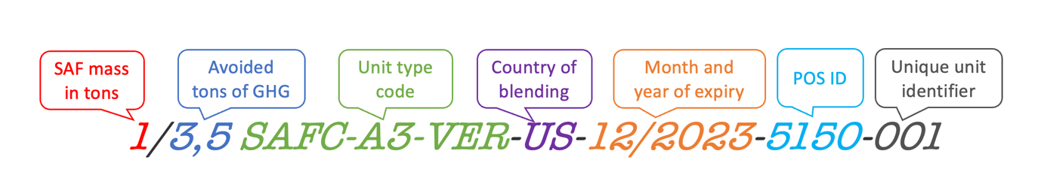
Exhibit 1: SAFc Unit ID Structure

SAF End-user Reduction Claims (SERcs)
- One SERc represents the end-user claims pertaining to one metric ton of neat (i.e., unblended) SAF.
- When displaying a SERc on an account, the Retirement Table (see 8.3), or the Retirement Statements, the Registry shall always show the LCA GHG reduction value alongside the metric tons of neat SAF value. When displaying multiple SERcs in one block of units, the Registry shall show the cumulative value of metric tons of SAF represented alongside the cumulative value of LCA GHG reductions represented.
- Each SERc shall always be represented with the following data elements:
  - LCA GHG emissions reduction value: The difference between the life-cycle (well-to-wake) GHG emissions of fossil jet fuel as estimated under CORSIA (89 gCO₂e/MJ) and the neat SAF in gCO₂e/MJ. In the case of VAL units, this is the validated LCA GHG reduction value, whereas in the case of VER units, this is the verified LCA GHG reduction value (see Unit Types). The SERc shall always indicate whether this LCA GHG value is VAL or VER.
  - Unit type code: Differentiates between types of SERcs defined under 3.4.
  - Month and year of expiration, as defined under 3.7.
  - Proof of sustainability (POS) ID: An identification number that serves to distinguish the SAF production process that generated the underlying SAFc.
  - Unique identifier: Differentiates a SERc from all other SERcs. The unique identifier contains the unique serial number of the underlying SAFc (note that multiple SERcs of smaller quantity may be derived from a single SAFc).
Exhibit 2 below provides an example of a SERc Unit ID:

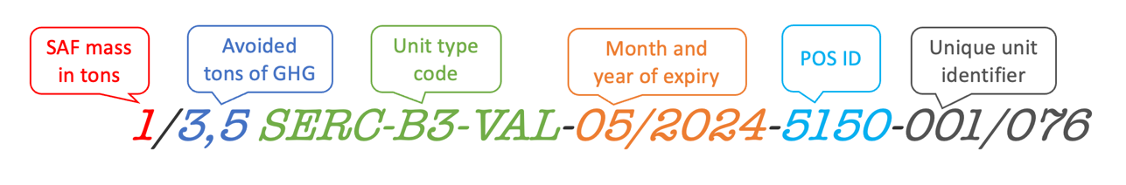
Exhibit 2: SERc Unit ID Structure

Unit Types
- The unit type is a characteristic of the unit that provides information related to the sustainability aspects of the unit, independent of unit status (which describes the unit’s state in the Registry).
- There are three dimensions of SAFc unit types, all of which are represented in the unit type code. The possible SAFc unit type codes and the processes that allow changing the unit type are mapped out in Exhibit 3. The dimensions within SAFc unit types and their possible values are as follows:
  - The type of sustainability standard that the SAFc meets as determined at SAFc issuance (see 6.2), as indicated by a letter:
    - “C” indicates an SCS-eligible SAFc, i.e., a SAFc representing SAF that meets the criteria established by an SCS holder.
    - “B” indicates a SABA-eligible SAFc, i.e., a SAFc representing SAF that meets the criteria for SABA-eligible SAF under SABA’s SAF Sustainability Framework.
    - “A” indicates a SABA-preferred SAFc, i.e., a SAFc representing SAF that meets the criteria for SABA-preferred SAF under SABA’s SAF Sustainability Framework.
  - Applicability for voluntary and/or compliance claims, as indicated by a number:
    - “1” indicates a SAFc that is applicable only for compliance use by air transport providers. Every SAFc is initially issued with this number, but this can change through various processes (see 7.2).
    - “2” indicates a SAFc that is only applicable for voluntary use and indicates that no SERc has yet been issued based on this unit.
    - “3” indicates a SAFc that is only applicable for voluntary use and indicates that a SERc was already issued based on this unit.
  - Position of the SAFc relative to the audit cycle of the associated SAF supplier(s), as indicated by “VAL” or “VER”:
    - “VAL” indicates that a SAFc has been validated, i.e., that it reflects the environmental attributes of a SAF supply chain that has been independently certified ex ante (i.e., prior to unit issuance) and that the details of this certification match the information visible on the Registry with respect to that SAFc, but that this information has not yet been verified in an ex post audit (i.e., after unit issuance).
    - “VER” indicates that a SAFc has been verified, i.e., that it reflects the environmental attributes of a SAF supply chain that has been independently certified ex post (i.e., after unit issuance) in addition to ex ante (i.e., before unit issuance). Verified information shall be reflected on every SAFc when available, even after unit retirement, but shall not replace the validated information. The verification process is described under 3.6.

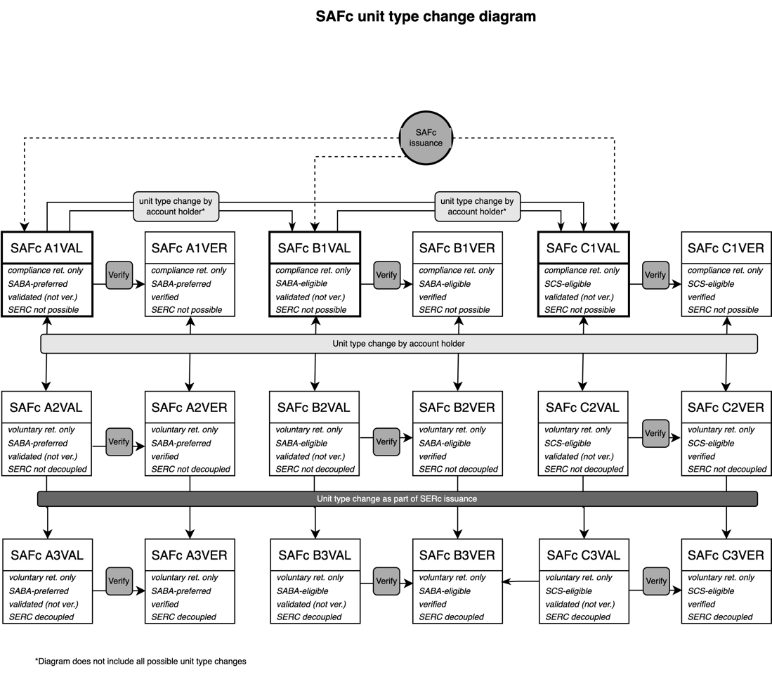

Exhibit 3: SAFc Types and Type Changes

- There are three dimensions of SERc unit types, all of which are represented in the unit type code. The possible SERc unit type codes and the processes that allow changing the unit type are mapped out in Exhibit 4. The dimensions within SERc unit types and their possible values are as follows:
  - Level of sustainability criteria met as determined at the issuance of the underlying SAFc, indicated by a letter:
    - “C” indicates an SCS-eligible SERc, i.e., a SERc based on SAFc representing SAF that meets the criteria set by an ICAO-recognized SCS holder.
    - “B” indicates a SABA-eligible SERc, i.e., a SERc based on SAFc representing SAF that meets the criteria for SABA-eligible SAF under SABA’s SAF Sustainability Framework.
    - “A” indicates a SABA-preferred SERc, i.e., a SERc based on SAFc representing SAF that meets the criteria for SABA-preferred SAF under SABA’s SAF Sustainability Framework.
  - The retirement status of the underlying SAFc:
    - “2” indicates that the underlying SAFc is not yet retired.
    - “3” indicates that the underlying SAFc is already retired.
  - Position of the underlying SAFc relative to the audit cycle of the associated SAF supplier(s), as indicated by VAL or VER:
    - “VAL” indicates that the SAFc underlying the SERc has been validated.
    - “VER” indicates that the SAFc underlying the SERc has been verified.

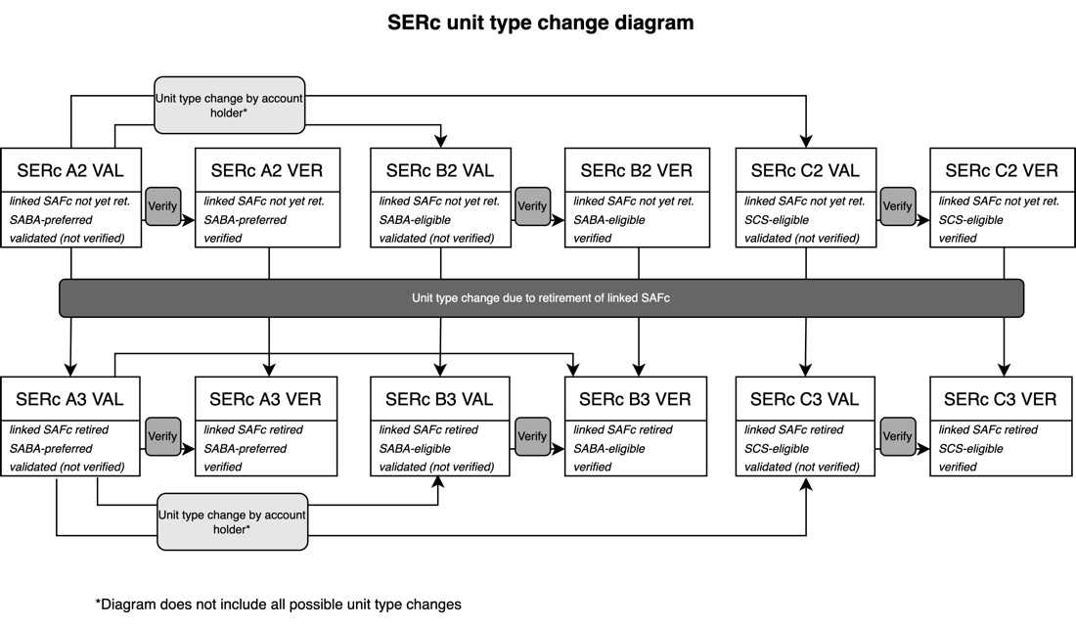
Exhibit 4: SERc Types and Type Changes

Sustainability Criteria at SAFc Issuance
- The sustainability criteria dimension of a unit type is determined at SAFc issuance (see 6.2) through a set of declarations by the fuel provider account holder on the Registry interface.
- For a unit to be issued as SCS-eligible (Type C), the holder of the fuel provider holding account (FPHA) must declare that:
- A certification body has certified that the SAF meets the sustainability criteria as defined by an ICAO-recognized SCS holder.
- A certification body will verify ex post that the SAF’s lifecycle carbon intensity value is calculated correctly in accordance with the default or actual LCA calculation methodology as defined in the SCS. For instance, CORSIA-certified fuels would be verified with respect to the CORSIA Default Life Cycle Emissions Values for CORSIA Eligible Fuels or the CORSIA Methodology for Calculating Actual Life Cycle Emissions Values.
- All participating operators in the supply chain of the SAF are certified to a SCS.
- For a unit to be issued as SABA-eligible (Type B), the holder of the FPHA must declare that:
  - All the requirements for demonstrating SCS eligibility set out under paragraph ii) are met.
  - A certification body has certified that the SAF meets the full set of sustainability criteria approved by the ICAO Council, which includes appropriate certifications across all participants in the supply chain.
  - The SAF was not produced to meet a compliance obligation, and no financial support for the SAF production was obtained from the government support mechanisms listed in Annex C.
- The LCA GHG Value of the SAF is not higher than 35.6 gCO₂e/MJ and thus achieves at least a 60% GHG emissions reduction compared to fossil jet fuel as estimated under CORSIA (89 gCO₂e/MJ). Adherence to this requirement is automatically verified by the Registry. Avoided emissions and removals do not count toward the SAF’s LCA GHG value.
- For a unit to be issued as SABA-preferred (Type A), the account holder must declare that:
- All the requirements set out under paragraphs ii) and iii) are met.
- If the SAF is made from land use–based feedstocks, the certification (issued by an ICAO-recognized SCS holder) demonstrates compliance with the ICAO Low Land Use Change (LUC) Risk Practices methodology detailed in the ICAO CORSIA Methodology for Calculating Actual Life Cycle Emissions Values.
- If the SAF is made from feedstocks designated under ICAO CORSIA as wastes, residues, and by-products in instances where displacement may pose an indirect land use change (ILUC) risk, the SAF has attained certification to the RSB Low ILUC Risk Biomass Criteria and Compliance Indicators (RSB-STD-04-001), or an equivalent standard from another ICAO-recognized SCS.
- If the SAF is made from feedstocks designated under ICAO CORSIA as wastes, residues, and by-products with non-ILUC displacement emissions, the SAF has attained certification to the methodology for displacement emissions detailed in the RSB Standard for Advanced Biofuels to demonstrate low ILUC risk and to quantify displacement GHG emissions. Note that the derived displacement emissions should be added to the life-cycle value of the SAF.
- The veracity of the declarations pursuant to the paragraphs above is subject to ex post verifications in accordance with 3.6.

Required declarations | SCS-eligible SAFc (Type C) | SABA-eligible SAFc (Type B) | SABA-preferred SAFc (Type A)
A certification body has certified that the SAF meets the sustainability criteria as defined by an ICAO-recognized SCS holder. | X | X | X
A certification body will verify ex post that the SAF LCA Value is calculated correctly in accordance with the default or actual LCA calculation methodology as defined in the SCS. | X | X | X
All participating operators in the supply chain of the SAF are certified to an SCS. | X | X | X
A certification body has certified that the SAF meets the full set of sustainability criteria approved by the ICAO Council, which includes appropriate certifications across all participants in the supply chain. |  | X | X
The SAF was not produced to meet a compliance obligation, and no financial support for the SAF production was obtained from the government support mechanisms listed in Annex C. |  | X | X
The LCA GHG Value of the SAF is not higher than 35.6 gCO2e/MJ and thus achieves at least 60% GHG emissions reduction compared to fossil jet fuel. |  | X | X
If feedstock is land-use based, the certification demonstrates compliance with ICAO LUC Risk Practices Methodology |  |  | X
If feedstock is waste/residue/by-product where displacement may pose an ILUC risk, the SAF has certification to RSB Low ILUC Risk Biomass Criteria and Compliance Indicators (RSB-STD-04-001), or equivalent SCS standard |  |  | X
If feedstock is waste/residue/by-product with non-ILUC displacement emissions, the SAF has certification to the methodology for displacement emissions as per the RSB Standard for Advanced Biofuels to demonstrate low ILUC risk and to quantify displacement GHG emissions |  |  | X

Exhibit 5: Sustainability declarations by sustainability standard type

Validated and Verified Units
- A unit is considered to be validated if it was issued. Issuance implies that:
  - The account holder requesting the issuance has a valid and active certification from an SCS
  - The Registry checked the information provided for the issuance request for internal consistency and conformity with the unit type requirements under 3.4
- A unit is considered to be verified if a certification body has conducted an ex post review of the issuing account’s certification and has in the course of this process:
  - Audited the veracity of the declarations made in accordance with 3.5
  - Audited the LCA value applied to the unit
  - Introduced the necessary changes in the Registry in accordance with 7.1

Unit Validity Period
- A SAFc shall be valid for X months after its issuance.
- A SERc shall be valid for X months after the expiry of the underlying SAFc.
- Units shall expire when they reach the end of their validity period.

Unit Status
- Unit status refers to the state of a unit at a given time within the Registry, independent of its type, which refers to sustainability characteristics.
- A unit can have the following statuses: active, retired, withdrawn, suspended, or expired.
- A unit changes status automatically as the result of a transaction (retirement or withdrawal, see 6) or process (suspension, revocation of suspension, or expiry, see 7). Exhibit 5 below shows the relationship between unit statuses and the related processes and transactions.
- The status of the unit is visible to the account holder of the account where the unit currently is or where it last was in active status.

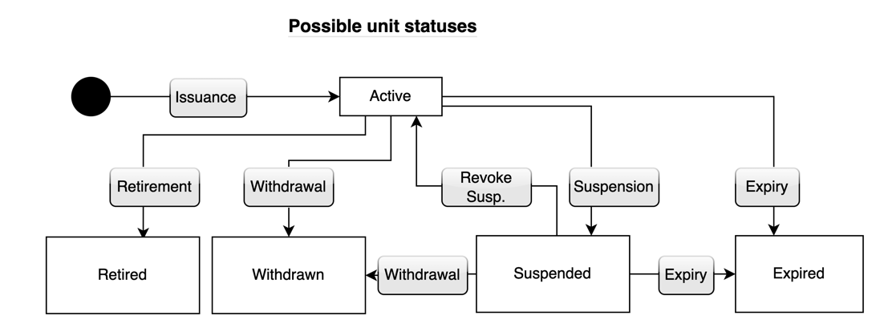
Exhibit 7: Possible Unit Statuses

Accounts and Account Holders

Account Types
- The Registry shall contain the following account types:
  - Fuel provider holding account (FPHA): An FPHA is capable of requesting issuance of SAFcs and SERcs, and can hold and transfer them. Any legal person who meets the account opening requirements set out under 4.3 and 4.5 may open an FPHA.
  - Air transport provider holding account (AHA): An AHA is capable of holding, acquiring, transferring, and retiring SAFcs and SERcs. Any air transport provider that meets the account opening requirements set out under 4.3 and 4.4 can open an AHA.
  - General holding account (GHA): A GHA is capable of holding, acquiring, and transferring SAFcs and SERcs. It may also retire SERcs for its own use and SAFcs on behalf of an air transport provider. Any legal person who meets the account opening requirements set out under 4.3 and 4.4 can open a GHA.
  - Freight forwarder holding account (FFHA): An FFHA is capable of holding, acquiring, and transferring SAFcs and SERcs. It may retire SERcs as a freight forwarder — i.e., by designating itself as the freight forwarder beneficiary and another account or person as the end-user beneficiary of the retirement. It may also retire SAFcs on behalf of an air transport provider. Any legal person who meets the account opening requirements set out under 4.3 and 4.4 can open an FFHA.
- The Registry shall also contain system accounts, which are held and managed by the Registry Administrator and used for various system-related purposes. Such accounts include administrator holding accounts, retirement accounts, and withdrawal accounts.
- Each account may hold the unit types and engage in the transactions identified in Exhibit 6.
- Each account holder may designate a set of other trusted accounts. Transactions to trusted accounts take place with simplified security requirements. Accounts owned by the same company (see 4.3) and system accounts are automatically considered trusted accounts.
- Each account shall be identified by a unique account identification number (Account ID), consisting of the following elements:
  - Unique account serial number
  - Account type identifier

 | Units that may be held on the account |  | Transactions that may be initiated from the account
 | SAFc | SERc | Request issuance of SAFc? | Request issuance of SERc? | Transfer SAFc/  SERc? | Retire SAFc? | Retire SERc? | Withdraw SAFc/SERc?
General holding account (GHA) | Yes | Yes | No | Yes | Yes | Yes* | Yes | Yes
Freight forwarder holding account (FFHA) | Yes | Yes | No | Yes | Yes | Yes* | Yes | Yes
Air transport provider holding account (AHA) | Yes | Yes | No | Yes | Yes | Yes | Yes | Yes
Fuel provider holding account (FPHA) | Yes | Yes | Yes | Yes | Yes | No | No | Yes
Exhibit 6: Permitted Units and Transactions by Account Type
Note: An asterisk (*) means that this account type can perform this action on behalf of another user but cannot use the associated claim for the account holder company’s own emissions disclosure.

Account Status
- Accounts shall be in one of the following statuses: “active,” “blocked,” or “closed.”
- Blocked or closed accounts may not issue, transfer, retire, withdraw, or receive any units. A closed account may not be reopened, whereas a blocked account may be reopened if the conditions for blocking are no longer present.
- Exhibit 7 shows the relationships between account statuses.

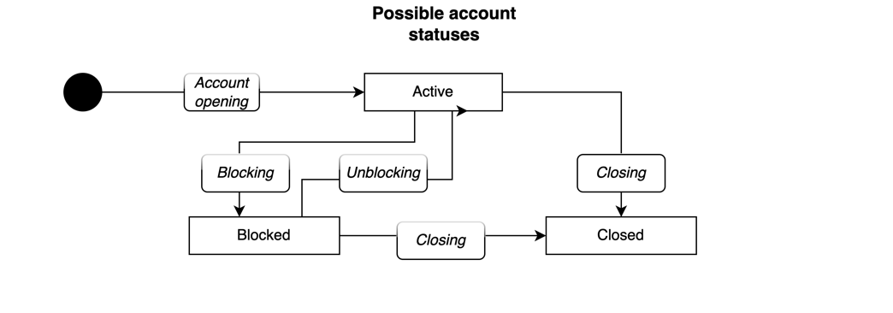
Exhibit 7: Possible Account Statuses

Setting up a Company in the Registry
- A legal entity (i.e., company) wishing to open accounts in the Registry shall submit to the Registry Administrator the information set out in Annex A: Information to Be Provided for Establishing a Company in the Registry, and, with respect to the company representative(s), shall provide the information set out in Annex B: Company Representatives and Authorized Representatives.
- The company representative (CR) is a natural person nominated by the prospective account holder (i.e., company) to manage accounts and authorized representatives on behalf of the legal entity holding the account. CRs will not have the right to see account holdings or initiate transactions. Every company shall have at least one CR. A CR can also be nominated as the authorized representative of one or more accounts belonging to the legal entity represented by the CR.
- When setting up a company, the CR will also be required by the Registry Administrator to sign the Terms and Conditions of Use, which shall cover, inter alia, the following:
  - Help desk availability times and process completion times
  - The terms and conditions regarding any registry fees for establishing and maintaining accounts and carrying out transactions
  - Provisions relating to disputes between account holders
  - Provisions relating to conflicts of interest between certification bodies and account holders
  - Changes to Terms and Conditions as required by changes to this Rulebook or other legal changes
  - Limitations of liability for the Registry Administrator and the account holder
- One account holder may hold multiple accounts, but one account shall have only one account holder. Account holding is not transferable.
- Each company will be identified with a unique company identifier.

Opening Fuel Provider Holding Accounts
- A fuel provider may request the opening of an FPHA from the Registry Administrator by providing:
  - Proof of an active RSB trader certification
  - Proof of ownership of fuel whose supply chain is certified to an SCS that is applicable for SAF
  - The expiry date of the certification
- Multiple FPHAs can be covered by a single certification. A fuel provider should establish a separate FPHA for every fuel producing facility, so that each account corresponds to an active set of certifications. In the event that an entity that is not a fuel provider holds an active trader certification and would like to request issuance of SAFcs with respect to SAF in its ownership, it shall open an FPHA in addition to its AHA or GHA.
- Upon opening, the FPHA shall designate a certification body already registered in the Registry in accordance with 5.1 as the certification body in charge of the FPHA’s audits. FPHAs may change their certification body by removing their current certification body and designating a new one. When an FPHA has no active certification body designated to its account, it shall not be able to issue SAFcs. In the event that a single FPHA is linked to multiple active certifications for a given facility, an FPHA may have multiple linked certification bodies at a given time that audit to different types of certifications.
- The Registry Administrator shall open the account or refuse account opening within 30 calendar days of the receipt of the complete set of information required.

Opening Other Accounts
- The CR may request the opening of an AHA, GHA, or FFHA by submitting the information required under Annex A: Information to Be Provided for Establishing a Company in the Registry. The CR may only request the opening of an AHA if it is representing an Air Transport Provider.
- When requesting the opening of the account, the CR shall nominate two ARs in accordance with 13.2. Detailed rules on ARs are set out under 13.3.
- The Registry Administrator shall verify whether the information and documents provided for account opening or registration are complete, up to date, accurate, and true. The Registry Administrator shall open the account or refuse account opening within 30 calendar days of the receipt of the complete set of information required.
- The Registry Administrator may refuse to open an account:
  - If the information and documents provided are incomplete, out of date, inaccurate, or false
  - If the Registry Administrator has knowledge that the nominated authorized representative (AR) is under investigation for or has been convicted of fraud, money laundering, terrorist financing, or other serious crimes for which the account may be an instrument.
  - If the Registry Administrator has reasonable grounds to believe that the accounts may be used for fraud involving allowances, money laundering, terrorist financing, or other serious crimes.

Blocking an Account
- The Registry Administrator shall block an account if:
  - the account holder has failed to pay the account management fees despite repeated notifications; or
  - the account holder has otherwise violated the terms and conditions of account holding; or
  - the account holder has not agreed to changes to terms and conditions of account holding despite repeated notifications; or
  - the account holder did not notify the administrator about changes to account information or provide evidence concerning changes to account information or concerning new requirements on account information; or
  - the Registry Administrator considers that the opening of the account should have been refused or that the account holder no longer meets the requirements for the opening of the account; or
  - in the case of an FPHA, the account holder’s certification has expired.
- The Registry Administrator may block an account if the Registry Administrator or a law enforcement agency has reasonable grounds to believe that the account was used or will be used for fraud, money laundering, terrorist financing, corruption, or other serious crimes.
- The Registry Administrator shall unblock the account once the reasons that gave rise to blocking are eliminated. Unblocking is subject to a fee, except in cases where the blocking has happened in accordance with ii).

Closing Accounts
- The Registry Administrator shall close an account at the request of the account holder within 10 calendar days, provided that the account holds no active units and the account holder has no unpaid account fees.
- The Registry Administrator may close an account if the account has been blocked for over 12 months and no active units remain on the account.

Certification Bodies and Auditors

Registering a Certification Body in the Registry
- An entity engaged in auditing and providing certifications for fuel providers (a certification body) may request its registration in the Registry by providing:
  - The information required for establishing a company representative set out under Section 12
  - Proof of its authorization (accreditation) under an SCS to audit fuel providers
- The Registry Administrator shall register the certification body or refuse registration within 30 calendar days of the receipt of the complete set of information required.
- CRs of certification bodies shall nominate auditors by providing all the information required for authorized representatives in accordance with Section 13. These auditors shall be able to carry out the verification process on the SAFcs that were issued by the FPHA to which the certification body is designated.
- The Registry Administrator shall de-register the certification body at its request within 10 calendar days. It shall also de-register the certification body if the certification body has ceased operation or its authorization to certify has expired or has been revoked.

Transactions

General Rules for All Transactions
- Each account type may only initiate the transactions permitted for it as set out in Exhibit 6.
- When a transaction is proposed, the Registry will check for irregularities or errors and may block transactions if they do not meet the requirements set out in this Rulebook. Such checks would ensure — inter alia — that the recipient account exists and is not blocked and can hold the units in the transaction, that the units to be transferred have not expired, and so on.
- Each transaction shall have a unique transaction ID that consists of a transaction type code, a date, and a unique serial number.

Issuance of SAFcs
- The holder of an FPHA may request the issuance of SAFcs by providing the information set out under Annex D: Information to Be Provided by the Fuel Provider When Requesting the Issuance of SAFc on the Registry interface. The holder of the FPHA may only request the issuance of SAFcs with respect to SAF that is in its legal ownership at the time of issuance. Units can be issued after the blending of the SAF or fuel certification for nonblended fuels.
- The holder of the FPHA must also declare that information submitted on the Registry interface is true and correct and in line with the SAF’s proof of sustainability (POS) document. The POS must also be uploaded to the Registry in a computer-readable PDF format, and the FPHA must have an active certification body designated to it.
- The Registry will conduct automated validity and system checks on the issuance request. If the issuance request passes the automated validity and system checks, the Registry will check in the Table of Certifications described under 8.1 if the producer of the fuel and potentially other supply chain stakeholders have the valid certifications required for the issuance of SAFc of a specific unit type.
- If the checks described under iii) are passed, the Registry will prompt the requesting FPHA to indicate the sustainability level of the SAFc to be issued (Type A, B, or C). The Registry will then prompt the account holder to make the necessary declarations set out under 3.5.
- If the declarations under iv) are made, the Registry will issue the corresponding SAFcs to the FPHA requesting the issuance. The information about the issued SAFcs is recorded on the Proof of Sustainability Table.

Issuance of SERcs
- The holder of a Type 2 SAFc may request the issuance of a SERc based on that SAFc. A holder of a Type 1 SAFc can convert it into Type 2 SAFc and thus forego the possibility of the SAFc being used for compliance by an air transport provider. When this type 1 to 2 conversion is done by an FPHA or a GHA, the SAFc is preset for voluntary use only.
- An account holder that has retired a Type 2 SAFc may also request the issuance of a SERc based on that SAFc within the validity period of the SERc set out under 3.7.
- When the SERc is issued, the Registry will change the unit type of the underlying SAFc from 2 to 3.

Transferring Units
- The holder of an open account that is holding units may request the transfer of these units to another open account by designating the units to be transferred and providing the Account ID of the recipient account. After conducting the necessary system checks, the Registry will request that the holder of the recipient account confirm acceptance of the transfer. If acceptance is confirmed within 48 hours (not including weekends), the Registry will carry out the transfer. If no confirmation is received, the transaction will fail.
- If the transfer is directed to a trusted account, no confirmation of acceptance is required from the recipient account.
- The moment of transfer constitutes the definitive legal transfer of ownership of the unit, regardless of any underlying contracts, agreements, outstanding payments, or disputes between holders of the transferring and receiving accounts or any third parties. Unless ordered by court decision to do so, the Registry will not transfer any units from any accounts in recognition of claims made by third parties.

Retirement of SAFcs
- The holder of an AHA, GHA, or FFHA may request the Registry to retire an active SAFc on its account.
- If the retiring account is an AHA, the Registry will request that the holder of the AHA make declarations on whether the retirement is for international or domestic purposes.
- If the retiring account is a GHA or an FFHA, it shall designate an AHA on whose behalf the SAFc is retired, and the Registry will prompt that AHA to indicate whether the retirement is for domestic or international purposes.
- If the unit being retired is a Type 1 SAFc (i.e., retirement is for compliance purposes), the Registry will request that the account holder designates the government compliance regime the retirement is intended for.
- If the unit being retired is a Type 2 SAFc (i.e., retirement is for voluntary purposes, but a SERc is not yet decoupled), the retiring account may designate an end-user for the associated end-user claims (i.e. SERc). The end-user may be:
  - The retiring account holder itself
  - Other accounts (other than an FPHA)
  - Legal or natural persons with no account in the Registry
- If the unit being retired is a Type 3 SAFc (i.e., retirement is for voluntary purposes, but a SERc is already decoupled), the Registry will change the unit type of the linked SERcs from 2 to 3.
- After conducting the necessary system checks, the Registry will move the SAFc to the retirement account and add a record of the retirement to the Book and Claim Retirement Table described in 8.3.
- If the retiring account is an FFHA, the Registry will also record it as a freight forwarder beneficiary in addition to the end-user(s) designated in accordance with paragraph v).
- If the account holder has designated an end-user, the Registry will issue a SERc and will immediately retire it on behalf of the designated end-user. If the account holder has not designated an end-user, the Registry will issue a SERc to the account of the account holder.

Retirement of SERcs
- The holder of an AHA, GHA, or FFHA may request the Registry to retire an active Type 3 SERc (i.e., a SERc where the underlying SAFc was already retired) on its account.
- When requesting retirement, the account holder shall designate the year for which the retirement shall apply, i.e., the year in which the account holder intends to report claims about the environmental attributes of the SAF. This year is either the year in which the SAFc was issued or any year following that up until the time of the SERc retirement.
- When requesting retirement, the account holder may designate an end-user for the associated end-user claims. The end-user may be:
  - The retiring account holder itself
  - Other accounts (other than an FPHA)
  - Legal or natural persons with no account in the Registry
- After conducting the necessary system checks, the Registry will move the SERc to the retirement account and add a record of the retirement to the Book and Claim Retirement Table described in 8.3.
- If the retiring account is an FFHA, the Registry will also record it as a freight forwarder beneficiary in addition to the end-user beneficiaries.

Processes

Verification
- Upon completing the ex post audit of the certification of the FPHA that has issued the SAFc, the auditor designated to the FPHA that has issued the SAFc shall add the verified LCA value to the POS Table. When this happens, the Registry shall automatically:
  - Update the LCA value in the unit ID of the SAFc and any SERcs issued on the basis of the SAFc
  - Change the unit type from VAL to VER of the SAFc and any SERcs issued on the basis of the SAFc
- On the basis of the ex post audit, the auditor may also:
  - Correct data in the POS information connected to the SAFc
  - Adjust the SAFc’s sustainability level by changing the unit type from A to B or from B to C if it finds that the unit does not meet the requisite sustainability criteria. Changes to the SAFc’s unit type shall be automatically followed by a change in the unit type of any connected SERc
  - Suspend the SAFc if it is impossible to correct the errors of the unit in any other way
- The auditor may implement the change of SAFc type from VAL to VER within X years of issuance. If this period is missed, the POS Table will show at the place of the verified LCA value a “timeout” message, indicating that verification was not completed within the available time.
- After the deadline above has passed, the Registry Administrator may add the verified LCA value to the unit at the request of the auditor, provided that the auditor has provided reasonable grounds for the delay (e.g., the verification was delayed due to a grievance mechanism).

Unit Type Conversion by an Account Holder
- An account holder may unilaterally and unconditionally change some elements of the unit type of units it holds. In particular, the following changes are permitted:
  - SAFc A1 to B1 or C1; and A2 to B2 or C2
  - SAFc B1 to C1; and B2 to C2
  - SAFc 1 to 2 and back (compliance unit to voluntary unit and back). SAFc can only be changed from Type 2 to Type 1 if no associated SERc has yet been issued
  - SERc A to B or C
  - SERc B to C
- These unit type changes will not affect the verification status of the unit.
- The account holder–initiated unit type changes are mapped out in Exhibit 3 and Exhibit 4.

Suspension and Unsuspension of Units
- The Registry Administrator may suspend a unit if it has reasonable grounds to suspect that some irregularity or criminal activity took place during the issuance, transfer, or retirement of the unit. A suspended unit may not participate in any transactions or processes.
- The Registry Administrator may unsuspend a unit if the suspicions are proven to be unfounded.
- Suspension shall not have an impact on the unit’s expiry date.
- Certification bodies may also suspend units described in paragraphs i) and ii) with respect to units issued from FPHAs to which they are designated. Unsuspension in the case of such units must be carried out by the Registry Administrator.

Withdrawal, Deletion, and Expiry
- Withdrawal of a unit means that the unit is removed from circulation and the underlying SAF becomes available for a new unit issuance. Withdrawal of a SAFc also causes any linked SERcs to be withdrawn. If all the SERcs related to a SAFc are withdrawn, the underlying SAFc is converted from a Type 3 to a Type 2 SAFc.
- The holder of an open account may request the withdrawal of active units on the account by designating the units to be withdrawn. The withdrawn units will be transferred to the Registry’s Withdrawal Account without making any record on the Retirement Table.
- The Registry Administrator may also withdraw units that were previously suspended in accordance with 7.3 if it finds that irregularities or criminal activities took place during the issuance, transfer, or retirement of the unit and that these cannot be remedied otherwise.
- Deletion of units means the permanent removal of the unit from the Registry system. The Registry Administrator may delete expired or retired units for administrative, security, data management, or privacy purposes.
- The Registry shall automatically set to expired status any unit that has reached the end of its validity period in accordance with 3.7.

Tables

The Table of Certifications
- The Table of Certifications contains information on all entities that hold SCS certifications, which may be required for opening fuel provider holding accounts in accordance with 4.1 and for requesting issuance of SAFcs in accordance with 6.2.
- The Table shall clearly indicate the relevant SCS, the scope of activities to which the certification applies, the expiry date of the certification, the certification body of the certification, and whether the certification is active or has been suspended.
- The Table of Certifications is regularly updated by the Registry Administrator using data from SCSs.

The Proof of Sustainability (POS) Table
- The purpose of the Proof of Sustainability (POS) Table is to ensure that SAFcs remain traceable to information regarding the production, certification, and blending of the underlying SAF during their lifetime and in retirement.
- The POS Table shall contain for each issued SAFc all the information set out under Annex D: Information to Be Provided by the Fuel Provider When Requesting the Issuance of SAFc. It shall also assign a unique SAF proof of sustainability ID to all SAFcs issued with the same batch number in the same facility.
- The holder of a SERc shall have access to all the information in the POS Table that is related to the SAFc linked to that particular SERc.
- The holder of a SAFc shall have access to all the information in the POS Table that is related to that particular SAFc.

The Book and Claim Retirement Table
- The Book and Claim Retirement Table shall contain the information set out in Exhibit 8.
- Once recorded, information in the Book and Claim Retirement Table may not be changed, unless:
  - Updates were required as part of unit verification (see 7.1)
  - The information was entered as a result of fraud or some kind of noncompliance, or in the context of adding end-users to retirements in accordance with 6.6.

No. | Item on the Book and Claim Retirement Table
For SAFc retirements
1 | Number of retired SAFcs
2 | Unit ID (including unit type) of retired SAFcs (POS ID hyperlinked to POS Table)
3 | Total validated GHG reduction value of retired SAFcs (by transaction or by company for a given period)
4 | Verified value of 3, when available
5 | Was SAFc retirement for domestic or international purposes?
6 | Name of SAFc retiring company (hyperlinked to Table of Certifications)
7 | Year for which SAFc retirement was made
8 | Subsidy scheme used for SAF production
9 | Was retirement for voluntary or compliance purposes?
10 | If voluntary: name of company entitled to end-user claims (i.e., SERc), if applicable
11 | If voluntary: name of company entitled to freight forwarder claims, if applicable
For SERc retirements
12 | Number of retired SERcs
13 | Unit ID (including unit type) of retired SERcs (POS ID hyperlinked to POS Table)
14 | Total validated GHG reduction value of retired SERcs (by transaction or by company for a given period)
15 | Verified value of 14, when available
16 | Name of SERc retiring company (hyperlinked to Table of Certifications)
17 | Name of company entitled to freight forwarder claims, if applicable
18 | Year for which SERc retirement was made

Exhibit 8: The Book and Claim Retirement Table

Confidentiality and the Public Website

Confidentiality
- All data in the Registry that is not expressly defined as public in this Rulebook is confidential. Confidential data will not be disclosed to anyone and will be accessible only to the staff of the Registry Administrator and auditors in specific cases, who will all sign nondisclosure agreements and shall access information only in connection with the execution of their duties.

Public Website of the Registry
- The public website shall display the public version of the SAF Proof of Sustainability Table and the Retirement Table in a searchable form. The public website shall not display information regarding X.
- The public website shall also display the following information on SAFc and SERc quantities:
  - The total number of all active units in the Registry, by unit type
  - The total number of units retired, separated by year of retirement
  - The total number of all expired units
  - The total number of all withdrawn units

Statements of Retirements
- An account holder may request the Registry to issue an electronic document that provides printable proof that a particular SAFc or SERc was retired.
- The document shall contain a link to the public website that points to the Public Retirement Table.
- Such electronic statements shall be protected against manipulation with a QR code or other means that the Registry Administrator may consider expedient.
- Retirement statements shall be issued with a disclaimer indicating that the statement is merely an extract from the Registry on the day it was issued and is not definitive proof of the up-to-date information held in the Registry.

Technical Requirements of the Registry

IT Requirements of the Registry
- The Registry shall be scalable to be able respond to increases in usage.
- Each transaction and process in the Registry shall be logged, and a full audit trail shall be available for all of them.
- The Registry shall conduct internal checks on all processes to ensure that technical requirements are met, inconsistencies are prevented, and the rules set out in this Rulebook are adhered to.
- The Registry shall be protected against breaches of IT security, such as viruses, hacks, and other cyberattacks. In particular, the Registry shall use two-factor authentication to authenticate CRs and ARs when using the system.
- The Registry shall ensure that data is protected against unauthorized manipulation and that any change in data is automatically and securely recorded using journaling and auditing functionality.

Availability and Reliability of the Registry
- The Registry shall strive to be available to be accessed by account holders 24 hours a day, seven days a week, and ensure that service interruptions are kept to a minimum.
- The Registry shall run in IT facilities that provide state-of-the-art backup facilities in the event of a breakdown in the operations of the primary hardware and software.
- The Registry shall safeguard all relevant data and ensure that data and operations may be promptly recovered in the event of a failure or disaster.
- The Registry’s public website shall be continuously available except for unavoidable service interruptions. The public website shall be updated at least once every 24 hours.
- The Registry shall have a help desk that shall be available at the times specified in the Terms and Conditions of Use.

Management of the Registry

The Registry Administrator
- The Registry Administrator is a professional IT organization engaged to manage the Registry.
- The Registry Administrator is responsible for the overall management of the Registry. In this capacity, the Registry Administrator:
  - Shall take all reasonable steps to ensure the availability of the IT infrastructure as set out under 10.2
  - Shall open, block, or close an account, review and approve ARs, and permit changes to account details that require the approval of the administrator in accordance with this Rulebook
  - Shall operate or contract the operation of the help desk for the Registry
  - May initiate transactions on accounts if instructed by the AR of the account, or a relevant law enforcement authority, in accordance with this Rulebook
  - Shall ensure that requests and inquiries made by ARs are promptly addressed
  - Shall decide possible accounting conflicts and undo transactions made by mistake
  - Shall collect registry fees from account holders
- The Registry Administrator is authorized to carry out any transaction on any account in the system, within the limits of the account management terms.
- The Registry Administrator may be subject to regular audits to ensure that the requirements described in this Rulebook are consistently implemented by the Registry Administrator.
- The Registry Administrator cannot be an entity that holds an account in the Registry or one that acts as a certification body.

The Registry Governance Board
- The Registry Governance Board consists of board members from a broad range of stakeholders invited to serve for a fixed period of time.
- The Registry Governance Board shall provide guidance to the operations of the Registry when necessary.
- The work of the Registry Governance Board shall be supported by a secretariat, who is in charge of convening and chairing meetings.

Annex A: Information to Be Provided for Establishing an Entity in the Registry
- When requesting the establishment of a company, the requesting legal person must provide the Registry Administrator with the following:
  - The information set out in Exhibit 9
  - Proof that the company has an open bank account in the United States or in a country from which it is possible to freely transfer funds through the SWIFT system to the United States, e.g.:
    - A document proving the registration of the legal entity
    - Bank account details
    - VAT-registration number, US TIN number, or other tax identification number applicable in the country where the legal entity is registered
    - The name, date of birth, and nationality of the legal entity's beneficial owner
    - List of directors
- The Registry Administrator may also require the following additional documentation:
  - A copy of the annual report or of the latest audited financial statements, or, if no audited financial statements are available, a copy of the financial statements stamped by the tax office or the financial director
  - Evidence to support the registered address of the legal person account holder, if this is not clear from the documents submitted under paragraph i)
  - The criminal record, or any other document that can be used to verify the nominee’s criminal record, of the beneficial owner and/or the directors of this legal person
- The evidence required above might be supplied through submitting originals, digitally certified copies, or copies certified by a notary public. If the documents are not in English, the Registry Administrator may require a certified translation of the documents.

 | A | B | C | D | E
 | Company info item | Mandatory (M) or optional (O)? | Type | Can be updated? | Update requires admin approval?
 | Company name | M | Free | Yes | Yes
 | Company address — country | M | Choice | Yes | Yes
 | Company address — region or state | O | Free | Yes | Yes
 | Company address — city | M | Free | Yes | Yes
 | Company address — postcode | M | Free | Yes | Yes
 | Company address — line 1 | M | Free | Yes | Yes
 | Company address — line 2 | O | Free | Yes | Yes
 | Company registration number | M | Free | Yes | Yes
 | Company telephone 1 | M | Free | Yes | No
 | Company telephone 2 | O | Free | Yes | No
 | Company email address | M | Free | Yes | No
 | ICAO Air Transport Provider Code (for air transport providers) | M | Free | No | n.a.
 | VAT registration number with coun­try code or Tax ID | M | Free | Yes | Yes

Exhibit 9: Account Details to Be Provided for Company Registration

Annex B: Company Representatives and Authorized Representatives

Setting up a CR
- The prospective account holder must provide the following to the Registry Administrator when nominating a company representative (CR):
  - A statement from the legal representative of the account holder or prospective account holder indicating that it wishes to nominate a particular person as CR
  - The information set out in Exhibit 10, which must be entered on the Registry interface
  - Evidence to support the identity of the nominee, such as an identity card, passport, or other personal identification document
  - Evidence to support the permanent address of the nominee, such as an identity card or other government document, or, in the absence of these, a statement from local authorities confirming the nominee’s permanent residence, or any other document that is customarily accepted as evidence of permanent residence
  - The police extract of the criminal record of the nominee, or any other document or declaration that can be used to verify the nominee’s clean criminal record
- The evidence required above might be supplied through submitting scanned copies of originals, digitally certified copies, or copies certified by a notary public. If the documents are not in English, the Registry Administrator may require a certified translation of the documents.

Setting up an AR
- The CR must provide the following to the Registry Administrator when nominating an authorized representative (AR):
  - The information set out in Exhibit 10, which must be entered by the CR on the Registry interface
  - Evidence to support the identity of the nominee, such as an identity card, passport, or other personal identification document
  - Evidence to support the permanent address of the nominee, such as an identity card or other government document, or, in the absence of these, a statement from local authorities confirming the nominee’s permanent residence, or any other document that is customarily accepted as evidence of permanent residence
  - The police extract of the criminal record of the nominee, or any other document or declaration that can be used to verify the nominee’s clean criminal record
- The evidence required above might be supplied through submitting scanned copies of originals, digitally certified copies, or copies certified by a notary public. If the documents are not in English, the Registry Administrator may require a certified translation of the documents.

 | A | B | C | D | E
Item no. | Account detail item | Mandatory (M) or optional (O)? | Type | Can be updated? | Update requires admin approval?
1 | First name | M | Free | Yes | Yes
2 | Middle name | O | Free | Yes | Yes
3 | Last name | M | Free | Yes | Yes
4 | Title | O | Choice | Yes | No
5 | Job title | O | Free | Yes | No
6 | Employer name | O | Free | Yes | No
7 | Department at the employer | O | Free | Yes | No
8 | Country of residence | M | Choice | Yes | Yes
9 | Region or state | O | Free | Yes | Yes
10 | City | M | Free | Yes | Yes
11 | Postcode | M | Free | Yes | Yes
12 | Address — line 1 | M | Free | Yes | Yes
13 | Address — line 2 | O | Free | Yes | Yes
14 | Phone number 1 | M | Number | Yes | No
15 | Phone number 2 | O | Number | Yes | Yes
16 | Email address | M | Free | Yes | Yes
17 | Date of birth | M | Date | No | -
18 | Place of birth — city | M | Free | No | -
19 | Place of birth — country | M | Choice | No | -
20 | Type of identity document | M | Choice | Yes | Yes
21 | Identity document number | M | Free | Yes | Yes
22 | Identity document expiry date | M | Date | Yes | Yes
23 | National registration number | O | Free | Yes | Yes
24 | Rights as authorized representative | M | Choice | Yes | Yes

Exhibit 10: Information to Be Provided on CRs and ARs

Rights of ARs
- Authorized representatives (ARs) can access accounts and may initiate transactions or approve transactions initiated by another authorized representative. Every account shall always have at least two ARs, and the CR shall determine their respective transaction initiation and approval rights.
- In addition to the ARs specified above, the CR may also designate persons with read-only access to accounts.
- A CR may decide that transfers to trusted accounts may be authorized by a single AR.
- All ARs shall receive notifications of all transactions initiated or approved by all other ARs.
- Auditors may initiate processes on their own, without the approval of another auditor from the same certification body.
- If an AR cannot access the Registry for technical or other reasons, the Registry Administrator, in accordance with the rights assigned to that AR, may initiate or approve transactions on behalf of the AR upon request, provided that the access of the AR was not suspended.
- CRs and ARs shall be natural persons over 18 years of age. All authorized representatives of a single account shall be different persons, but the same person can be an authorized representative on more than one account. A CR can also be nominated as the AR of one or more accounts belonging to the CR’s legal entity. CRs and ARs may not transfer their role to others.
- When requesting the opening of an account, the CR shall nominate ARs and, if the AR was not previously registered in the Registry, provide the information set out under Annex B to the Registry Administrator.
- The Registry Administrator shall approve or reject CR and AR nominations within 30 calendar days. This period may be prolonged once by another 30 days with a notification to the requesting entity if more time is needed for the evaluation of the documents.
- The Registry Administrator shall verify whether the information and documents provided for nominating an authorized representative are complete, up to date, and accurate.
- The Registry Administrator may refuse to approve a CR or an AR if the information and documents provided are incomplete, out of date, inaccurate, or false, or if the administrator has knowledge that the nominated AR is under investigation for or has been convicted of fraud, money laundering, terrorist financing, or other serious crimes for which the account may be an instrument.
- An AR may be removed from the account at the request of the CR, but only if there remain at least two authorized representatives. The CR may be removed from the legal entity’s accounts at the request of the account holder to the Registry Administrator, alongside the nomination of a new CR.
- The Registry Administrator may remove a CR or an AR if it considers that the approval of the AR should have been refused in accordance with the provisions of this Article, and in particular if it discovers that the documents and the identification information provided upon nomination were incomplete, out of date, or otherwise inaccurate or false.
- The Registry Administrator may suspend access to accounts of a CR or an AR if it has reasonable grounds to believe that the CR or AR has:
  - attempted to access accounts or processes for which they are not authorized;
  - repeatedly attempted to access accounts or processes with an incorrect username or password; or
  - attempted to compromise the security, availability, integrity, or confidentiality of the Registry and its data.

Updating Information on Accounts, Company Representatives, and Authorized Representatives
- CRs shall update any changes to account information on the Registry within 10 working days. Changes are subject to the approval of the Registry Administrator before taking effect.
- If the change requires evaluation by the Registry Administrator, the update shall be accompanied by the necessary supporting documentation. The documentation is evaluated by the Registry Administrator according to the procedures described under 13.1 and 13.2.
- The Registry Administrator shall regularly review if the submitted documentation is up to date (e.g., if identification documents have expired) and will notify account holders if an update is required.

Annex C: Government Support Mechanisms

- Use of the following government support mechanisms for the production of SAF precludes classification as SABA-eligible or SABA-preferred in accordance with 3.5:
  - X
- The use of any government support mechanism for the production of SABA-eligible or SABA-preferred SAF that is not listed in paragraph i) above is expressly permitted.

Annex D: Information to Be Provided by the Fuel Provider When Requesting the Issuance of SAFc (POS INFO)

- In accordance with 6.2, the information set out in Exhibit 11 must be provided on the Registry interface when requesting issuance of SAFc.

 | A | B
 | Data item | Note
1 | Batch number
2 | Fuel/material type
3 | Info on feedstock
4 | Feedstock name | Select from list
5 | Type of feedstock (land-use based, other?) | Select from list
6 | Type of feedstock (waste/residue/by-product?) | Select from list
7 | Amount of neat, certified material in MJ
8 | Amount of neat, certified material in tons
9 | Statement of whether the raw material was certified as production residue or end-of-life product
10 | Date of acquisition and, if different from the date of acquisition, date of entry in the system user’s chain of custody tracking and management systems
11 | Location of acquisition site of certified material
12 | Name and address of supplier(s) (known as fuel provider in the registry)
13 | Name and address of most recent production or processing site
14 | Name and address of third-party management of previous production or processing site, when applicable
15 | Name of certification scheme
16 | Additional potential claims allowed under RSB certification system (e.g., Low ILUC Risk Biomass) if the product is RSB certified, when applicable
17 | Fuel provider’s valid certification number and name of certification body
18 | Chain of custody model employed at supplier’s most recent site
19 | Location of blending (country + address)
20 | Date of blending
 | Info on SAF LCA GHG value
21 | Do you use a) default or b) actual LCA GHG value? | Choose a) or b)
22 | If a) is selected in R21: Default LCA GHG value (gCO₂e/MJ) | Automatic by registry based on feedstock selection
23 | If a) is selected in R21: Avoided emissions and removals to be deducted from R16 | Manual
24 | If b) is selected in R21: Actual LCA GHG value (gCO₂e/MJ) | Manual entry
25 | If b) is selected in R15: Avoided emissions and removals to be deducted from R18 | Manual entry
26 | Name of neat SAF producer
27 | Production date of neat SAF
28 | Production location of neat SAF
29 | Conversion process
30 | Default induced land use change value (gCO₂e/MJ)
31 | Disaggregated values for direct land use change (DLUC), landfill emission credit (LEC), and recycling emission credit (REC) included in the LCA GHG value (gCO₂e/MJ)
32 | Feedstock origin, with SCS detail when applicable
33 | Country of SAF uplifting or airport location for SAF blend delivery if different from country of SAF uplift
34 | Date of blending
35 | Information on government subsidies used in the course of producing the SAF (if any)

Exhibit 11: Data to Be Supplied for SAF Issuance Request (POS Info)

The authors of this document are Istvan Bart (EDF), Laura Hutchinson (RMI), and Chiudo Ehirim (RMI).
This Rulebook currently defines three distinct sustainability standards that the Registry will differentiate as part of the unit type classification. We foresee a potential need to add further sustainability criteria definitions in the future with user input and will structure a process to collect input from users on their needs in this regard.
This Rulebook currently defines three distinct sustainability standards that the Registry will differentiate as part of the unit type classification. We foresee a potential need to add further sustainability criteria definitions in the future with user input and will structure a process to collect input from users on their needs in this regard.
ICAO has recognized RSB and ISCC as SCS holders. RSB and ISCC-held SCSs include: RSB and ISCC CORSIA, RSB EU RED, ISCC EU, RSB Global, and ISCC Plus.
RSB and ISCC are the two ICAO-recognized holders of sustainability certification schemes (SCS). Eligible SCS under the SCS-eligible unit type include RSB and ISCC CORSIA, RSB EU RED, ISCC EU, RSB Global, and ISCC Plus.
The SABA-eligible definition is consistent with SBTi aviation sector guidance requirements for SAF (https://sciencebasedtargets.org/resources/files/SBTi_AviationGuidanceAug2021.pdf), but further specifies the SBTi-preferred level of emissions reductions relative to conventional jet fuel (60%).
See ISCC CORSIA 205, Section 6, on Low Land Use Change Risk Practices; or RSB CORSIA RSB-STD-12-001, Section 4.
If the certification is issued by RSB, meeting this requirement means that the certification includes the RSB-STD-04-001 standard (https://rsb.org/wp-content/uploads/2020/06/RSB-STD-04-001-ver-0.3-RSB-Low-iLUC-Criteria-Indicators.pdf).
The exact length of the validity periods for SAFc and SERc are yet to be determined. See the public consultation questionnaire for more context.
Applicable SCSs include RSB and ISCC CORSIA, RSB EU RED, ISCC EU, RSB Global, and ISCC Plus.
These requirements are based on Section 2.3.7 of the RSB Book & Claim Manual v3.0.
Note that if the fuel provider is also the fuel producer, such a check is not necessary, given that the FPHA would be blocked if the fuel provider’s certification had expired or been suspended.
The exact length of the period after which verification is not possible is yet to be determined on the basis of discussions with stakeholders.
To be determined on the basis of discussions with stakeholders.
To be completed
Note that some of the following requirements are transposed from the RSB Manual while some were added by SABA.
“Book & Claim,” RSB, https://rsb.org/book-claim/.
“Sustainable Aviation Buyers Alliance (SABA)”, flysaba.org.
Ibid.
“SARPs — Annex 16 Volume IV,” ICAO, 2018, https://www.icao.int/environmental-protection/CORSIA/Pages/SARPs-Annex-16-Volume-IV.aspx.
“Science-Based Target Setting for the Aviation Sector: Version 1.0,” Science Based Targets initiative, August 2021, https://sciencebasedtargets.org/resources/files/SBTi_AviationGuidanceAug2021.pdf.
“Greenhouse Gas Protocol,” https://ghgprotocol.org .
“SABA Sustainability Framework for Sustainable Aviation Fuel (SAF),” https://www.flysaba.org/files/2022/12/SABA-SAF-Sustainability-Framework_12.9.22.pdf
“ISO/DIS 22095: Chain of Custody — General Terminology and Models,” ISO, 2019, https://www.iso.org/obp/ui/#iso:std:iso:22095:dis:ed-1:v1:en.
Ibid.
Ibid.
“CORSIA Eligible Fuels,” ICAO, last modified November 2022, https://www.icao.int/environmental-protection/CORSIA/Pages/CORSIA-Eligible-Fuels.aspx.
“SABA Sustainability Framework for Sustainable Aviation Fuel (SAF),” https://www.flysaba.org/files/2022/12/SABA-SAF-Sustainability-Framework_12.9.22.pdf
Ibid
“CORSIA Default Life Cycle Emissions Values for CORSIA Eligible Fuels,” ICAO, June 2022, https://www.icao.int/environmental-protection/CORSIA/Documents/CORSIA_Eligible_Fuels/ICAO%20document%2006%20-%20Default%20Life%20Cycle%20Emissions%20-%20June%202022.pdf.
“CORSIA Methodology for Calculating Actual Life Cycle Emissions Values,” ICAO, June 2022, https://www.icao.int/environmental-protection/CORSIA/Documents/CORSIA_Eligible_Fuels/ICAO%20document%2007%20-%20Methodology%20for%20Actual%20Life%20Cycle%20Emissions%20-%20June%202022.pdf.
“ICAO Council Approves CORSIA Sustainability Criteria for Sustainable Aviation Fuels,” ICAO, November 12, 2021, https://www.icao.int/Newsroom/Pages/ICAO-Council-approves-CORSIA-Sustainability-Criteria-for-sustainable-aviation-fuels.aspx.
“SABA Sustainability Framework for Sustainable Aviation Fuel (SAF),” https://www.flysaba.org/files/2022/12/SABA-SAF-Sustainability-Framework_12.9.22.pdf
“RSB Methodology for Displacement Emissions: Version 1.0,” RSB, December 7, 2018, https://rsb.org/wp-content/uploads/2021/09/18-12-13_RSB-STD_04-002-Methodology-for-displacement-effects.pdf.

